**TITLE OF THE MINI PROJECT:**

* SUPER MARKET BILLING.

**INTRODUCTION:**

* Supermarket billing system is a very simple mini project in C, built as a console application without using graphics features.
* Supermarket billing is used for billing the items brought by customer to the billing counter.
* This project main task is to save the billing customer name, mobile number, and total bill.
* This project is used to make the billing of the items and the payment method used by the customer.
* **DESCRIPTION ABOUT FUNCTIONS USED IN THE PROJECT:**
* The project contains common header files stdio.h,stdlib.h and string.h .
* User defined function used in the function are:

**1)** void payment(int)

**2)** int data(int)

**3)** int items()

**4)**void welcome()

* This project contains structures concept for collecting name and mobile number of customer ; files concept for storing the details of customer name , mobile number and total bill ; arrays and pointers concept for calculation of addition of cost of each item; if , else if , else concepts for calculating the discounts and finally loops concept for cash payment method .

**PROJECT CODE:**

#include<stdio.h>

#include<string.h>

#include<stdlib.h>

struct customer

{

char name[50];

char phone[10];

}c1;

void payment(int);

int data(int);

int items();

void welcome();

int main()

{

int sum,res;

welcome();

sum=items();

res=data(sum);

payment(res);

return 0;

}

void welcome()

{

FILE *fp;

int res;

printf("\n");

printf("=======================================================\n");

printf("\n");

printf("============WELCOME TO HAPPY SUPER MARKET==============\n");

printf("======IBRAHIMBAGH , GOLCONDA , HYDERABAD-500008 =======\n");

printf("\n");

printf("=======================================================\n");

printf("\n");

printf("OFFERS OF OUR HAPPY SUPER MARKET ARE :\n");

printf("\n");

printf("1) FLAT 10 percent OFF ON A BILL OF RUPEES 1000 AND BELOW 2000.\n");

printf("2) FLAT 20 percent OFF ON A BILL OF RUPEES 2000 AND BELOW 3000.\n");

printf("3) FLAT 30 percent OFF ON A BILL OF RUPEES ABOVE 3000.\n");

printf("\n");

printf("=======================================================\n");

printf("\n");

printf("Enter customer details : \n");

printf("\n");

printf("Enter customer name : \n");

gets(c1.name);

printf("\n");

printf("Enter customer phone number : \n");

scanf("%s",c1.phone);

printf("\n");

fp=fopen("Display.txt","a");

fprintf(fp,"\n***Customer details:***\n");

fprintf(fp,"Name:%s\n",c1.name);

fprintf(fp,"Phone Number:%s\n",c1.phone);

fclose(fp);

printf("Your details are successfully stored in the database\n");

printf("customer name :");

puts(c1.name);

printf("\n");

printf("customer phone number : %s\n",c1.phone);

printf("==============================================================\n");

printf("\n");

}

int items()

{

int num,item[100],i,sum=0;

int *ptr;

ptr=item;

printf("Enter number of items purchased by customer:\n");

scanf("%d",&num);

printf("Enter the cost of each item one by one : \n");

for( i=0; i<num; i++)

{

scanf("%d",&item[i]);

}

for(i=0;i<num;i++)

{

printf("cost of item number : %d = %d ",i+1,*ptr);

printf("\n");

ptr ++;

}

for(i=0; i<num; i++)

{

sum= sum+item[i];

}

return sum;

}

int data(int sum)

{

int savings=0,amount=0;

if(sum<1000)

{

printf("\n");

printf("======================================================\n");

printf("========== YOU HAVE NOT AVAILED ANY DISCOUNT =========\n");

printf("Total cost of items is = %d\n",sum);

printf("Amount to be paid by customer is %d\n",sum);

printf("Your total savings are = 0 \n");

amount=sum;

printf("======================================================\n");

}

if((sum>=1000) && (sum<=2000))

{

savings=(0.1)*sum;

amount=sum-savings;

printf("\n");

printf("======================================================\n");

printf("========== YOU HAVE AVAILED 10 PERCENT DISCOUNT =====\n");

printf("Total cost of items is = %d\n",sum);

printf("Amount to be paid by customer is %d\n",amount);

printf("Your total savings are = %d \n",savings);

printf("======================================================\n");

}

if ((sum>2000) && (sum<=3000))

{

savings=(0.2)*sum;

amount=sum-savings;

printf("\n");

printf("======================================================\n");

printf("========== YOU HAVE AVAILED 20 PERCENT DISCOUNT =====\n");

printf("Total cost of items is = %d\n",sum);

printf("Amount to be paid by customer is %d\n",amount);

printf("Your total savings are = %d \n",savings);

printf("======================================================\n");

}

if(sum>3000)

{

savings=(0.3)*sum;

amount=sum-savings;

printf("\n");

printf("======================================================\n");

printf("========== YOU HAVE AVAILED 30 PERCENT DISCOUNT =====\n");

printf("Total cost of items is = %d\n",sum);

printf("Amount to be paid by customer is %d\n",amount);

printf("Your total savings are = %d \n",savings);

printf("======================================================\n");

}

return amount;

}

void payment(int amount)

{

FILE *fp;

int cash,num1,pin,change=0;

printf("\n");

printf("============{{{{{ TOTAL BILL = %d }}}}}============\n",amount);

fp=fopen("Display.txt","a");

fprintf(fp,"Bill amount:%d\n",amount);

fclose(fp);

printf("Your details are successfully stored in the database\n");

printf("\n");

printf("Choose the payment option to be made:\n");

printf("\n");

printf("Choose the payment option to be made:\n");

printf("\n");

printf("========================================================\n");

printf("\n");

printf("**press 1 for card payment**\n");

printf("**press 2 for cash payment**\n");

printf("\n");

printf("========================================================\n");

while (num1!=1 || num1!=2)

{

scanf("%d",&num1);

{

if(num1==1)

{

while (pin != 7171)

{

printf("ENTER YOUR SECRET PIN NUMBER:");

scanf("%d", &pin);

if (pin==7171 )

printf("\n");

printf("YOUR TRANSACTION FOR RUPEES %d IS SUCCESSFULLY COMPLETED",amount);

printf("\n");

printf("\n");

printf("***** THANK YOU FOR SHOPPING WITH US !! *****\n");

printf("\n");

printf("******* VISIT AGAIN !!! **********\n");

printf("======== ENTER CONTROL + Z TO COMPLETE BILLING PROCESS! =========\n ");

if (pin !=7171)

printf("* INVALID PIN, ENTER CORRECT PIN *\n");

}

}

else if (num1==2)

{

printf("Cash given by customer to cashier is :\n");

scanf("%d",&cash);

if(cash>=amount)

{

change=cash-amount;

printf("amount to be returned to customer is %d \n",change);

}

else

{

printf("===Given amount is less than total bill,sorry the billing has been cancelled===\n");

}

printf("\n");

printf("\n");

printf("***** THANK YOU FOR SHOPPING WITH US !! ****\n");

printf("\n");

printf("********************* VISIT AGAIN !!! ****************************\n");

printf("\n");

printf("====================================================================\n");

printf("\n");

printf("======== ENTER CONTROL + Z TO COMPLETE BILLING PROCESS! =========\n ");

}

else

{

printf("**INVALID CHOICE , PLEASE CHOOSE RIGHT OPTION**\n");

}

}

}

}

**TEST CASES:**

**1)** In the code execution ,first it displays the name of the supermarket and address of the supermarket where it is located.

**2)** Next it displays the discounts provided by the supermarket and next it asks to enter the number of items purchase by customer.

**3**) Next it asks to enter the cost of each item one by one.

**4)** Next the discount is calculated for the items and it displays the savings and total bill that to be paid by customer.

**5)** Finally it asks to choose the payment option either by cash or card i.e. credit or debit card.

**6)** Billing process gets cancelled if less money is paid.

**7)** Finally bill is generated.

**OUTPUT OF PROJECT:**

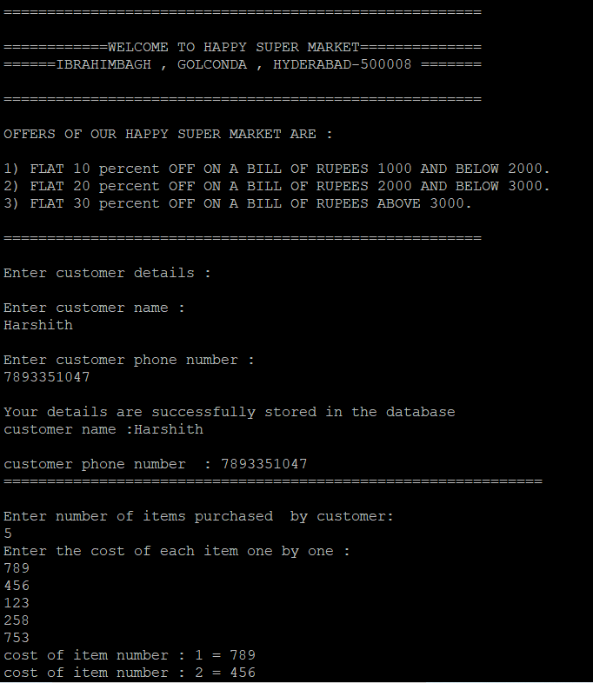

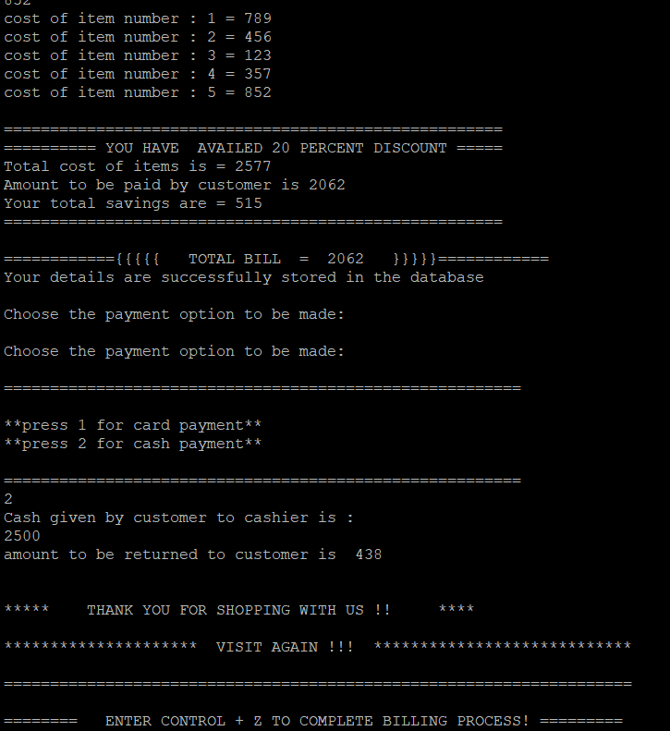

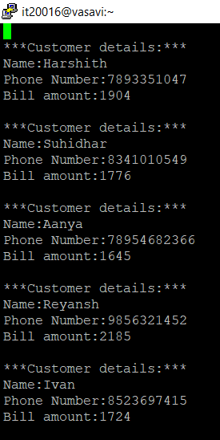

**THINGS LEARNT BY THIS PROJECT:**

* We learnt how to use the c language in real life time and this project helped us to learn various topics in c language.

**CONCLUSION:**

* we successfully completed the mini project **SUPER MARKET BILLING** using c language concepts like loops ,conditional statements ,arrays ,pointers ,structures , files etc.

**FUTURE SCOPE:**

* As we know that c is the base programming language which acts as a foundation of all other languages. As this project belongs to c code, we can expect a good scope in the future.
* This project helped us a lot and gave us the confidence so that we can built many other projects in future.

**\*\*\*\*\*\*\*\*\*\*\*\*\*\*\*\*\*\*\*\*\*\*\*\*\*\* THE END \*\*\*\*\*\*\*\*\*\*\*\*\*\*\*\*\*\*\*\*\*\*\*\*\*\*\*\*\*\*\*\*\*\*\*\*\***

* **DONE BY :**  **HARSHITH**

**SUHIDHAR**